AGREEMENT FORM

PAYMENT OF FEE(S) FOR THE COLLECTION AND DISPOSAL OF REFUSE FROM A GATED COMMUNITY

UNDER SECTION 12 AND THE SCHEDULE OF THE DISTRICT COUNCIL OF BLACK RIVER
(COLLECTION AND DISPOSAL OF REFUSE) REGULATIONS 2013 – GN 80 OF 2014 AS AMENDED
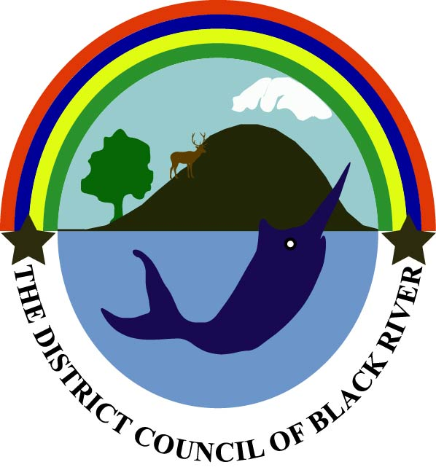

I ……………………………………………………………………………...................................

Bearing NIC No. ……………………………………….. and representing the syndic of ……
……………………………………………………………….……………………………………
at ……………………………………………………………………………………………………

hereby agree to pay the yearly sum of Rs 3600 per residential unit to the District Council of Black River for the collection of waste on a twice weekly basis from the above mentioned gated community as from …………………………………… as per provisions of the above regulations.

I undertake to pay to the Council the required fees as per this agreement and the provisions of the above mentioned regulations. I understand that in case of non-payment of the fees within the prescribed delay a surcharge of 10% will be levied on the amount due.

I undertake to inform the Council in advance whenever I would not require the collection service.

I agree to abide by the legislations in force governing the collection and disposal of refuse and to

any other concerned enactments.

NOTE:

The Council may stop the collection of waste or to enter legal action accordingly in case the fee(s) is not paid for services offered.

……………………………….. |  | ………………………………..
Signature of Trader/Occupier |  | Signature of Chief Executive
……………………………….. |  | ………………………………..
Date |  | Date

